Automated Demand Forecasting & Inventory Optimization Engine
Executive Summary
Developed an end-to-end data pipeline and machine learning solution for a large-scale e-commerce distributor managing 12,000 SKUs across 200 brands. The project automated the unification of fragmented sales channels and inventory data, replacing manual procurement processes with a predictive model that achieved 98% forecasting accuracy, significantly outperforming traditional human-led purchasing habits (81%).
1. The Business Challenge
The client faced a massive scaling bottleneck due to high operational complexity:
- Data Fragmentation: Sales and inventory data were siloed across multiple e-commerce platforms and 40 different manufacturers.
- High SKU Complexity: Managing 12,000 products with varying logistical requirements (PZN, EAN, GTIN), packaging types, and expiration dates.
- Variable Demand: Sales were highly sensitive to seasonality, delivery restrictions, and external market trends.
- Manual Inefficiency: Manual stock maintenance led to frequent overstocking (capital tie-up) or understocking (lost revenue).
2. Technical Architecture & Data Engineering
To solve the data silos, I built a robust ETL/ELT architecture using the Azure ecosystem:
- Ingestion: Orchestrated Azure Data Factory pipelines to ingest data via APIs and Databricks, ensuring regular synchronization from disparate sales channels and external market sources.
- Data Warehousing: Stored and structured the raw data into an MSSQL Data Warehouse.
- Unification & Normalization: * Unified sales data from multiple channels into a single "Golden Record" table.
  - Mapped fragmented product listings and inventory logs to a master product catalog.
  - Standardized logistical metadata including dimensions, weights, and SKU variants.
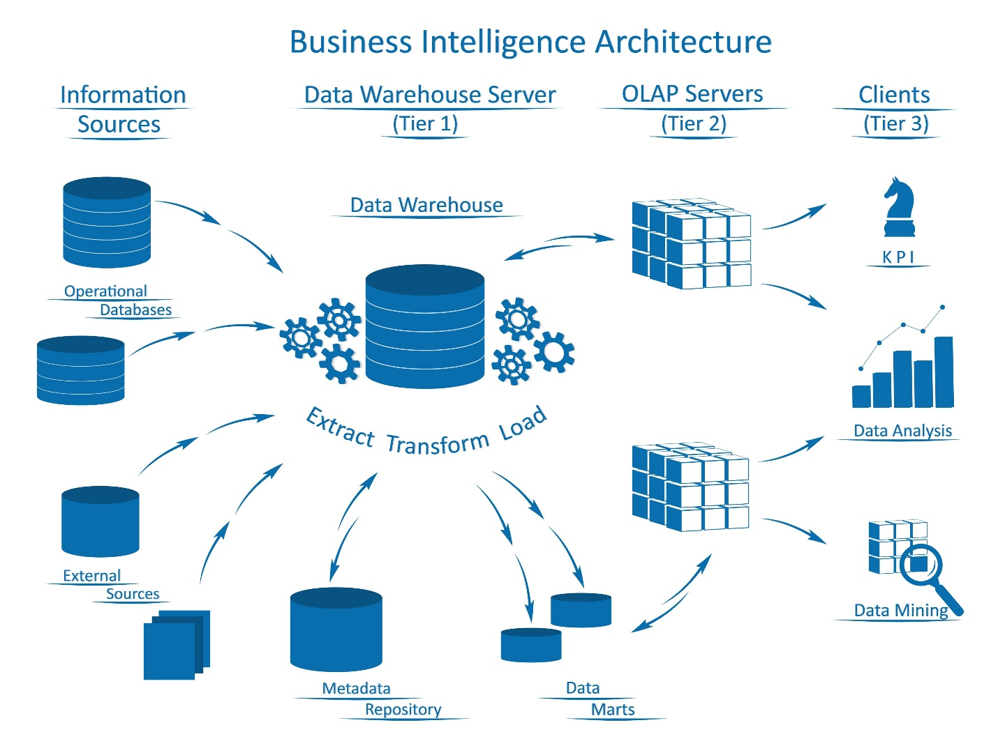
3. Predictive Modeling & Machine Learning
Once the data was normalized, I shifted focus to the predictive engine:
- Feature Engineering: Modeled sales data based on rolling windows (last 7, 30, and 90 days), year-over-year (YoY) comparisons, and category-level trends.
- External Intelligence: Integrated external API data to capture broader market trends and seasonal shifts.
- Model Selection: Implemented a Machine Learning model within Azure to generate automated replenishment suggestions based on customized matrices and parameters.
- Validation: Conducted rigorous backtesting by comparing forecasted numbers against historical inventory levels and actual sales performance.
4. Impact and Results
The transition from manual operations to an AI-driven approach yielded quantifiable improvements:
- Accuracy Benchmarking: * The initial model achieved 94% accuracy across all datasets.
  - After cleaning "data externalities" (poor listings/missing integration data), the model precision reached 98%.
- Operational Superiority: In backtesting, the model significantly outperformed human procurement specialists, who averaged 81% accuracy due to inconsistent overstocking/understocking.
- Efficiency: Automated the generation of invoices and stock listings, reducing manual labor and human error in the supply chain.
Tech Stack
- Cloud/Orchestration: Azure Data Factory, Databricks.
- Database: MSSQL (Data Warehouse).
- Languages/Tools: SQL, Python, Azure Machine Learning.
- Integrations: Shopify API, Amazon SP-API, External Market Trend APIs.

